Shiyali Ramamrita Ranganathan

August 9, 1892 - September 27, 1972

"All the books form a single unit. Indeed, they are like chapters of one huge book."

(S.R. Ranganathan, 1931)

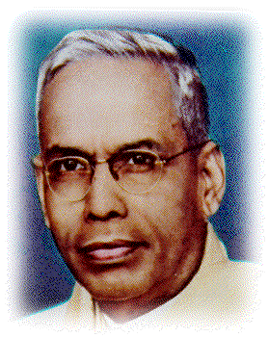

**Background:**

(By Anne Driscoll for IS490 - Dead Germans Project)

Shiyali Ramamrita Ranganathan was born in Madras, India in 1892. He earned a Bachelor of Arts degree in Mathematics in 1913 and a Master of Arts degree in Mathematics in 1916. He taught at Government College and the University of Madras' Presidency College until 1923. Like many people, S.R. Ranganathan had more than one career. At the age of 32, Ranganathan became the first librarian at the University of Madras. To train himself for the post, Ranganathan traveled to London where he studied Library Science at University College. His career as a librarian spanned almost 50 years. The first 25 years of his library career were spent in individual research. Ranganathan was a prolific writer. By 1931, he had written about 48 books. Many of his books have been reprinted 7 or more times. His books dealt with the following areas of library science:

Cataloging

Classification

Library Administration and Management

Library Organization

Reference Service

Ranganathan's work touched not only libraries in India but around the world. His *Five Laws of Library Science* have become a cornerstone of librarianship.

**Books are for use.**

**Books are for all; or every reader his book.**

**Every book its reader.**

**Save the time of the reader.**

**A library is a growing organism.**

In 1995 Michael Gorman and Walt Crawford formulated [Five New Laws of Library Science](http://www.ala.org/editions/openstacks/insidethecovers/insideexcerpts1a.html). "They are a reinterpretation of Ranganathan's truths in the context of the library of today and its likely future" (Crawford, 1995).

In addition to teaching in India, Ranganathan taught and conducted research in Europe and the United States. The sections below contain a synopsis of his career.

## Career in Brief:

1925 First librarian at the University of Madras.

1945 --1954 Librarian and Assistant Professor of Library Science at Hindu University, Varanasi, India.

1947 --1954 Librarian at the University of Delhi, Delhi, India.

1954 --1958 Research in Zurich, Switzerland.

1958 --1959 Visiting professor at Vikram University, Ujjain, India.

1962 Founds the Document Research and Training Centre, Bangalore, India. He was the head or associated with the center until his death in 1972.